Ideation Phase
Define the Problem Statements

Date | 29 June 2026
Team ID
Project Name | Darshan ease
Maximum Marks | 2 Marks

Customer Problem Statement Template:
Devotees visiting temples often face long waiting queues, overcrowding, and delays due to manual ticket booking and limited information about darshan slot availability. These challenges make the pilgrimage experience stressful and time-consuming, especially during weekends, holidays, and festival seasons.
Many devotees are unable to plan their visits efficiently because there is no centralized platform to check temple details, available time slots, make secure online payments, or receive instant booking confirmations. Temple administrators also struggle to manage large numbers of visitors, maintain booking records, and regulate crowd flow effectively.
DARSHAN EASE addresses these challenges by providing a secure and user-friendly web application that enables devotees to register, browse temples, check slot availability, book darshan tickets online, make secure payments, and receive digital tickets with QR codes. The system also helps temple administrators efficiently manage bookings, schedules, and visitor information through a centralized dashboard.
By understanding the needs and challenges of both devotees and temple administrators, the project aims to provide a smooth, transparent, and convenient temple darshan booking experience while reducing waiting times and improving crowd management.
.

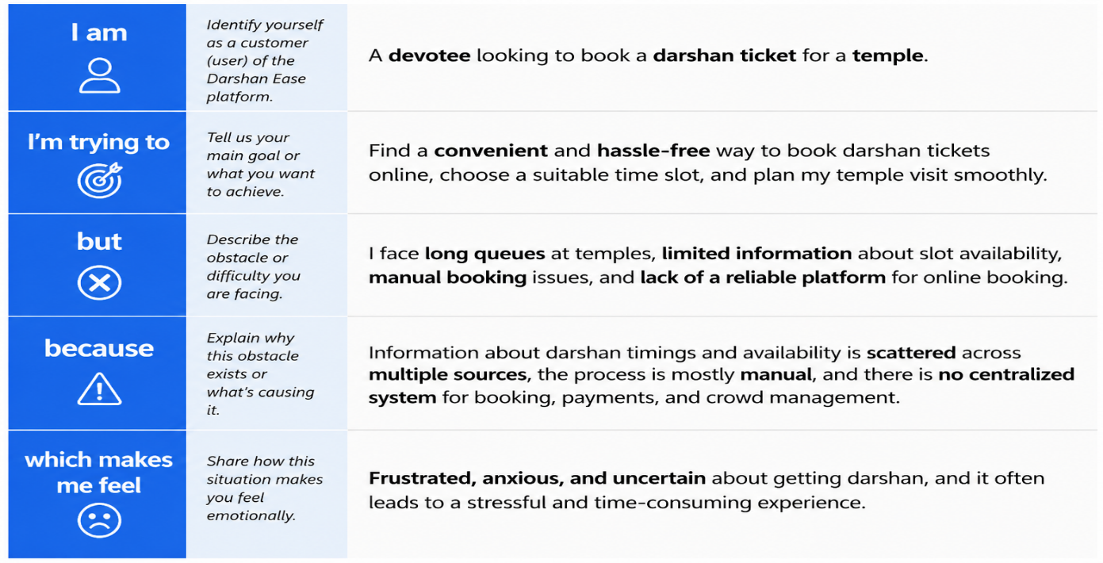

Example:
Problem Statement (PS) | PS-1 |  | PS-2
I am (Customer) |  | A devotee who wants to book a temple darshan ticket. | A temple administrator who manages darshan bookings and temple schedules.
I'm trying to | Book a darshan ticket online, choose a convenient time slot, and complete the payment quickly and securely. |  | Manage temple information, darshan slots, bookings, and devotee records efficiently through a centralized system.
But | I face long queues, limited information about slot availability, and manual booking processes that make planning difficult. |  | Managing darshan slots, booking records, and crowd flow manually is time-consuming and prone to errors.
Because | There is no centralized platform that provides real-time slot availability, secure online booking, digital tickets, and instant booking confirmation. |  | Traditional booking methods rely on manual records, making it difficult to track bookings, manage devotees, and prevent overcrowding.
Which makes me feel | Frustrated, anxious, and uncertain about getting a darshan slot, especially during weekends and festival seasons. |  | Overwhelmed and inefficient in managing temple operations, bookings, and visitor flow during peak periods.

